

گزینه 2

-------------------------------------------------------------------------------------------------------------------------------



گزینه3

-------------------------------------------------------------------------------------------------------------------------------

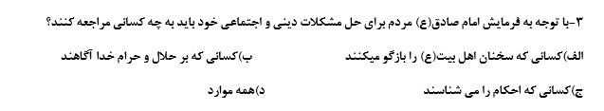

گزینه4

-------------------------------------------------------------------------------------------------------------------------------



گزینه4

-------------------------------------------------------------------------------------------------------------------------------



گزینه4

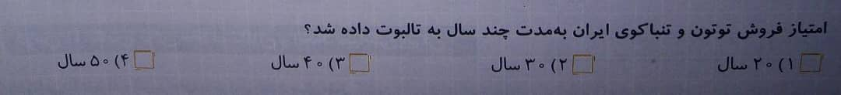

گزینه4

------------------------------------------------------------------------------------------------------------------------------



گزینه 2

------------------------------------------------------------------------------------------------------------------------------



گزینه 3

------------------------------------------------------------------------------------------------------------------------------

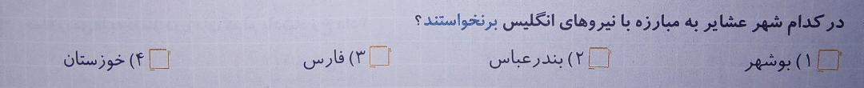

گزینه 2

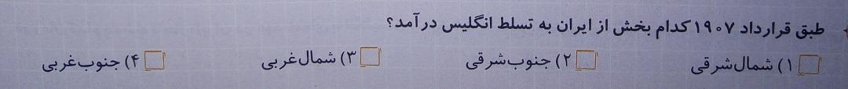

گزینه 2